**Conversation Guide: Digital Health Modernization Discovery Research**

**Bold text identify the moderator’s questions.**

*Text in italics are Emily’s observations and interpretations of the participant.*

[Text in brackets are interpretations in participants’ direct quote.]

**Background (5 minutes)**

To get started, I’d like to get a little background information about you, and your experience with the VA.

1. **Can you tell me a little bit about yourself?** My name is Michael, I have been in the Marine Corps for 13.5 years now in reserves for the past 2 years. I am working as a consultant for Booze Allen Hamilton. Currently supporting a client out in Los Angeles Air Force Base.

I have a wife and one kid, a boy 2 1/2 years. Were all healthy, no one in our household has been affected by COVID.

On the VA side I am 100 percent permanent and total. Most of that is due to PTSD which is 75% rating, and sleep apnea which was a 50% rating. Then I have back and joint issues, nerve pain issues. That has bothered me more than the PTSD and sleep apnea, because I have a CPAP machine, and I am on medication for depression and anxiety and they help with the PTSD. But the chronic pain is what kills me.

1. **When did you leave the military?** I am still in; I am a reservist. 11 years active duty, reserves the last 2 ½ years.
2. **Do you have any family members who you claim as dependents?** Yes.

**Do your family members receive any benefits from the VA?** So disability payment is increased because I have a wife and son but besides that there are no specific benefits that either of them, or I claim right now.

**Outside of disability, are there other benefits or things you receive from the VA?** I use it for mental health counseling and my wife and I will be starting marriage counseling program with them as well.

Then I used the VA home loan to buy my house.

**When did you use the home loan?** 2013 the first time we used it, then the second time we used it in 2019 and we refinanced with it last month.

**You mentioned mental health care, do you use VA for primary care?**  Not for primary care, because my family and I, we also use Tricare reserve select.

VA health care for me, I can use it for plenty of stuff and it would be fine but it wouldn’t work for my wife and son so that’s why still have TRICARE. So if I am paying for it I might as well use it. Because TRICARE lets me use anybody out in town, no need to wait for an appointment at the VA. I only use the VA for mental health services.

1. **Do you manage any of your VA benefits online?** Yes.

**Where do you do that?** eBenefits.

**Any portals for your health care, inside or outside the VA:** Yes, I’ve used video connect… or something like that? Yes, VA video connect. What’s the other one… *Participant looks at his other monitor, and is searching for something. Note that the participant has not mentioned MHV.*

**I’m just curious, how are you looking this up?** I am looking through my email to verify which service I used. Ok, so also VA video connect for my biweekly counseling. I use the web based on my laptop, but I have used the video connect app to connect for telehealth with the doctors.

**What was the experience like for VA Video Connect?** It has been fine; I haven’t needed anything other than the standard video function. Never had a multi-person call, I did not use the chat or file transfer. If it is Zoom or Webex, it could have been FaceTime and it would have been the same interaction.

**Difference between web and mobile app?** The web app was smoother. I have only used the mobile app a few times so I don’t have a clear memory of it but what little I remember it wasn’t running smoothly.

**For TRICARE, do you use any web tools?** Not really, just because my monthly premiums are on autopay and any deductibles come as paper bills in the mail.

Maybe once in a while I would need the referral letter, if I was doing something that required a referral. Then I’d go into their portal… So TRICARE West, that’s Health Net Federal Services, I’d go into the Health Net Federal Services portal for beneficiaries and download the referral letter to my inbox.

**For private providers, do you use any online tools for managing appointments or prescriptions, any of those types of tasks**? I will rarely, just to confirm they are in network vs. out of network I’ll go into the Health Net Federal services to make sure they’re in network providers. That’s about it for the most part.

**Does this look familiar? *Moderator shares her screen to show participant MHV.***

Yes, very familiar. I rarely to keep track of my appointments, because I enter them into my calendar as soon as I get them. Messages: I rarely get messages. Health Records: I already have them, and am rarely asked to download new copies of them. Pharmacy: on occasion I will use the Pharmacy tab to reorder my pain management meds. My mental health refills are done at my appointment with my psychiatrist. *Seems to rarely use MHV for any management needs; but understands the functionality.*

[00:10:14]

**I’m curious if you’ve used this website? *Moderator shows VA.gov.***

I have used it; it normally kicks me to another website so I just go to the primary website to start with.

**Mental model of health at the VA (20 minutes)**

Now I’d like to hear about your experience transitioning from the military to the VA. **(10 minutes)**

1. **I’m interested in how you first learned about the benefits available to you through the VA; specifically for your mental health care, how did you learn about those benefits?**

My last command while active duty was Marine Corps Intelligence Activity, and MCIA have many civilian employees and tend to be veterans themselves. They were the ones, when I was transitioning, they told me to get in contact with the VSO on base. And that gentlemen did a fantastic job, he basically held my hand Barney style, and walked me through the entire process. I tried at first on my own and it was a goat rope, then I got him to help and it was smooth sailing.

I did my entire claim and got all my exams scheduled prior to getting out. I did all my exams as soon as I was out, and had a rating within 4-5 months of being discharged. *Seems to be focusing on disability application process as opposed to health care enrollment, although moderator prompted for health care. This process seems to have prominence in the participants’ mind.*

I submitted all my claims prior to being discharged, it was retroactive. *Assuming he’s referring to retroactive payment on his disability compensation here.*

**What are you referring to in regards to claims and exams?** All of the paperwork that is with submitting a claim, medical records, affidavits for mental health. *Again, seems focused on disability application.*

I tried to do the VA forms myself, I am not saying the website or forms are intentionally obtuse, they are very detailed and technical and nature due to the law and all of the information required. To a degree, I get it, but for your average person that doesn’t know all of the details, ‘If you’re submitting this form, you need to read all fine print on page seven of the instructions that says you have to submit all of these other forms alongside of it.’ So they may have to do the process 4-5 times.

You have a VSO holding your hand, the VSO’s know the ins and outs and tell you where to sign then you are good to go.

1. **Tell me about the health care you receive through the VA?**

Ups and downs. Mental health services are good, it took time to get linked up with a provider. Partially my fault, partially the VA’s fault. The frustrating part was that I was entitled to my normal TRICARE prime benefits for the 6 months after I got off active duty. I was seeing a provider on the base at the LA Air Force Base and then that cut out, and it took a while to finally get with a VA provider full time. If I would have tried to get stated with the VA as soon as I had gotten out, as opposed to continuing to use my TRICARE benefits that I knew were going to run out, then that may have been a better play on my part.

The pain management side of the VA has been less than helpful, it has been very frustrating. So I have had to see private providers out in town using the TRICARE benefits for it. I understand the reticence when it comes to pain management provides prescribing opiates due to the opiate epidemic. I get it, I really, really do. I have been on chronic pain management meds for years. I normally have one bottle of Percocet on hand and a 30-pill bottle lasts me a year. So basically, I only take them when the pain is super extreme. I had been on that level of medication and had had that amount on hand for some time.

When I tried to transition to a VA pain provider and I informed then because I was almost running out. They told me flat out no and that they could provide the medication I am currently on for chronic pain. And I said if I have a flare up—I have been hospitalized due to the flare ups. They said they don’t know me and they don’t have a reason to prescribe it; essentially too bad so sad. *Describing ambivalence on the part of VA providers.*

I’m sorry, that’s bullshit. They should take the time to learn my case history and learn about me. I only talked to the junior doctor, then I asked to speak to the supervisor and they were even more defiant and belligerent. Which honestly only pissed me off even more.

After that I have never used them for pain management again. I have only stuck with providers out in town. I understand the opioid epidemic and not prescribing aggressively. If someone is addicted, 30 pills will not last them a year. It will last them a few days or a few weeks. I mean I have no idea, I’m making those numbers up, because I’m not addicted! It was very very poor patient management on their part. It wasn’t medical mal-practice, it was poor patient management.

**Tell me a bit about the attitude of not knowing your history.** The first doctor I was talking to was a junior doctor, and he said the VA doesn’t have a long established medical history with you, and we do not know what you have been taking and haven’t. We don’t currently know your injuries and how you have been treated. Based off of the symptoms you’re telling us, and the limited knowledge we do have, we don’t think prescribing opiates is the appropriate thing to do.

AndI understand that to a degree. But instead of saying no and ending it, if I tell you it had been done for years, lets find a way to get to yes. Let’s figure a way out to get to a yes together and he said there’s nothing they can do. Then I asked to talk to the supervisor, because every time he’d disappear for five minutes to talk to the attending, then come back and tell me no. Just get the attending so we stop this game of telephone. She seemed to be annoyed by my persistence, when she came on she was belligerent with me as well, she said its not happening, stop asking. That doesn’t tell me that she wants to get know her patient or why they are being persistent.

**Was this an issue with not having access to your records?** I mean I am pretty sure I pushed out my records from my out in town provider. *Confirmed that prior to going to the VA, had been using private provider through TRICARE.*

I had given them records from my out in town provider and I forgot where I was going with that…

1. **Since you first became a Veteran, has there been a change in the types of VA benefits you’ve received?** I have used their home loan program, mental health (psychology and physiatrist), attempted to use for pain management, a little bit for primary care provider, although I usually go to my out in town provider for my annual physical that is required.

I also use the VA for my CPAP, and hearing aid as well. *Is this separate from HC benefits?*

**You’ve gone through the VA to purchase that medical equipment?** They provide it; I don’t have to purchase it.

1. **How would you explain a “disability rating” to a new Veteran?** I think most vets and transitioning service members are used to the term “rating” or “disability rating.” So I would just use that term, percent disabled.
2. **What does that percentage mean or allow you to do?** For me and what I’d say for most other veterans, the things it effects are the amount of monthly financial compensation, federal hiring benefits you can be afforded, depending on your level [disability rating], and also what amount and type of health care the VA will provide to you based on your percentage and which conditions are service connected.
3. **In your mind, is there a relationship between “disability” and “health care”?** Yes, absolutely. I mean again the things that the VA has rated me disabled for, they now provide health care for. Because I am 100% permanent and total, they will even provide health care for things that are not related to my service-connected disabilities. But others that aren’t 100 percent P&T will be treated for their service connect disabilities.
4. **What is P&T?** *Participant asked if moderator was asking because she didn’t know, or because she wanted to see if he knew. Moderator explained that this was not a test of his knowledge, but because she hadn’t heard the term before.*

Permanent and total means the VA cannot change your rating for the rest of your life. P&T can only go with a 100 percent rating. If you are not P&T, they can rate you each year to see if your conditions have gotten worse or better and adjust your rating as such. If you’re 100% P&T, you never have to worry about the VA changing your rating at all.

It also then effects certain education benefits as well. I can’t remember if this is a state benefit for California or federal, but for some colleges if you are 100 percent P&T, your children can go to any college tuition free. You still have to pay housing and books, but the tuition is waived.

1. **When it comes to your health care, what is the most important thing you need from the VA?**

Mental health services. The mental health services provided through the VA…my psychologist is someone that was in the military himself and works regularly with vets. He can relate very well, or has experience with others that have gone through the same experiences.

Even for the psychiatrists, my psychiatrist has been dealing with veterans for years and she has a good understanding of the what meds go well with our particular traumas and symptoms. Instead of a random psychiatrist from out in town that may be well intentioned, but not have the veteran experience really dialed-in.

Whereas pain management, obviously I didn’t have a great experience at the VA. Audiology is audiology. Sleep apnea is sleep apnea. There’s nothing veteran-specific about those. Mental health services is by far the most important.

1. **Sounds like having someone that can relate to the experience is critical?** Yes.

Now I’d like to ask you how you manage information and tasks related to your health care. For each one, talk me through the steps you’d take. If there is something that you go online to complete, I may ask you to share your screen so I can see what you would do. **(10 minutes)**

**Tasks** Moderator should prompt about device usage if participant mentions digital tools or resources.

* **How would you reach out to your VA care team if you had a question?** I would go to VA.gov and sign in then navigate to…oh no, I would go to My HealtheVet and use the secure comms server.

***Moderator asks participant to show us that process.*** *Participant is on Mac, using Google Chrome browser.*

*We don’t see participant navigate to MHV; shares screen when MHV is already showing, clicks sign in, uses MHV credential (blue CTA) to sign in.*

**Do you always use that option to sign in?** I use it when I am on my computer because the password is saved. I have the DS logon, so I could do that. I rarely us ID.me and there’s no reason to use DS logon in particular with this site if I can login with My HealtheVet.

Then I can just go to compose message. *Participant selects Compose Message link under Messages from homepage.*

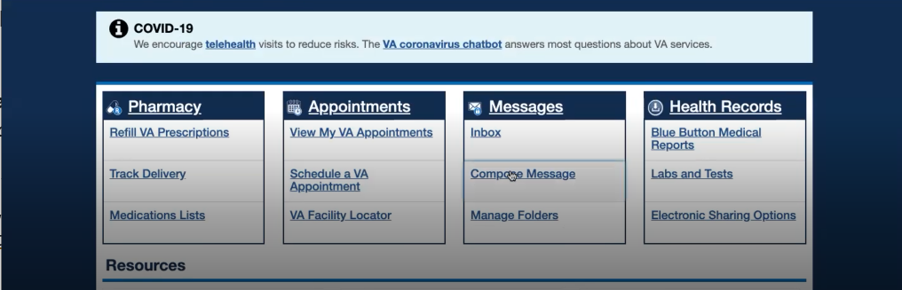

* **How would you refill a prescription you have with the VA?** *Navigates back to homepage, clicks Refill Prescription link under Pharmacy.*

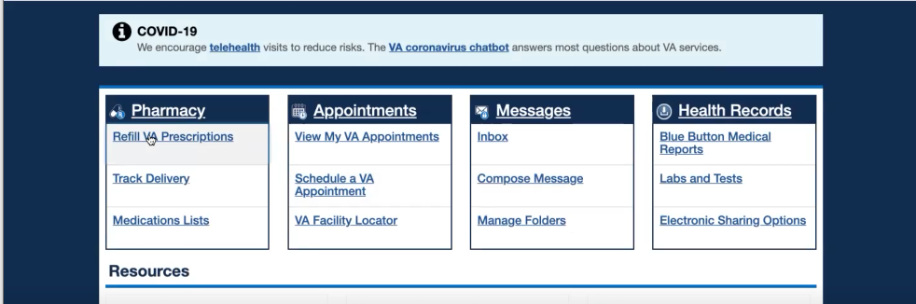

* **Is this how you primarily refill Rx?** Yes. I would click what I need refilled then hit submit. *Participant scrolls through his Rx table, indicating the check boxes and blue Submit CTA.*

*Note the participant mentioned at the beginning of the interview that he rarely needs to refill online; mental health Rx are refilled at psychiatry appts and pain management is primarily through non-VA providers.*

**Are they shipped or picked up?** I am busy during the day so they are shipped. Especially for the mental health ones I would need to drive to Long Beach and I am not wasting an hour and a half when they can be mailed to me.

**Ever tracked delivery for Rx?** I want to say no. I don’t think so.

* **How would you go about checking the date of an upcoming medical exam you have for a disability claim?** *Clicks view my VA appointments.* This site has everything you need right up front for the most part.

*Note: C&P exams do not appear on MHV appointments.*

* **How about an appointment for a yearly check up with your VA care team?** No, I would look in the same place.
* **(If applicable) Or a private provider (dentist, optometrist) outside the VA?** So I mean again as soon as I make appointments they are on my calendar in my phone then they send a reminder by text, email, or mail at least 7 days out.
* **Have you paid a VA health care bill, such as a copay?** No.
* **How would you request reimbursement from the VA for traveling to your health care appointments?** I don’t think I have every requested it for my regular VA appointments. When I did my initial ones to establish my rating [C&P exams] they automatically submitted it for me so I would get the $3 or $7 check to see the doctor. That’s been it.
* **How would you update the dependents on your VA benefits?** That one I would go back to eBenefits. *Participant clicked on MHV logo in header, clicked back in browser, before typing in eBenefits url. Perhaps he started in eBenefits and navigated to MHV from there before sharing screen?*

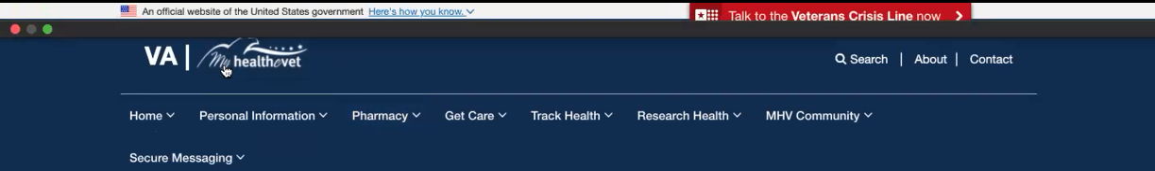

*Enters eBenefits URL, selects Log In. Checks box for consent to monitor, enters username and pw through LastPass. Receives an error for incorrect username or pw.*

**So here it looks like DS Logon is your only option?** You can use your CAC as well.

*Tries to use CAC option instead, receives another error message “This site can’t provide a secure connection.” Goes back to DS Logon and selects another pw using LastPass. Continues to security image. Lands on DS Logon profile page. Then selects ‘Websites Accepting DS LOGON’ tab.*



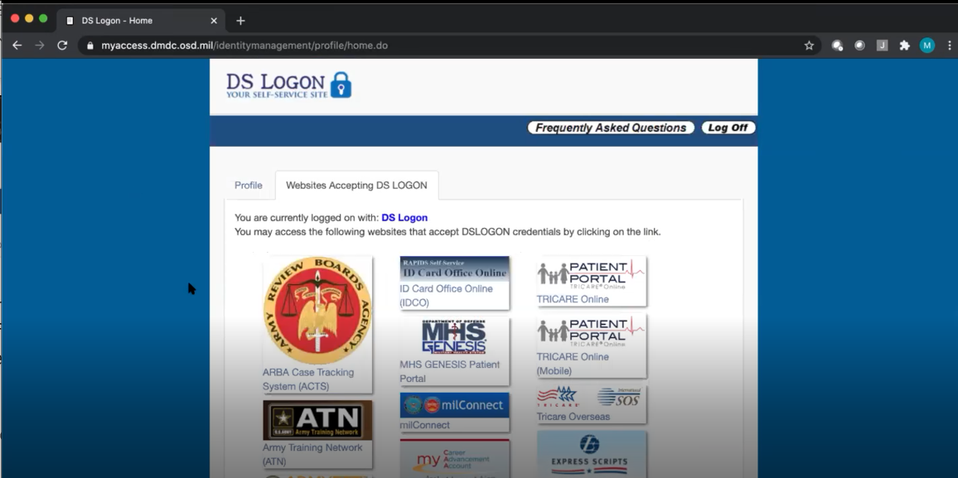

This is why I don’t like the DS logon because after that [logging in,] I have to come here and find the website I was trying to get to in the first place. If I can use the CAC or My HealtheVet direct logon I will use that because it takes me right to the page.

*Selects eBenefits from DS Logon page. Opens to Dashboard.*

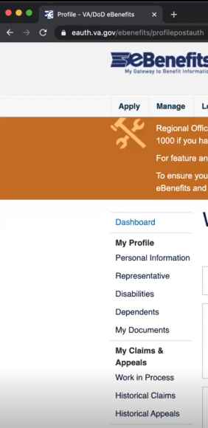

I would then go to dependents.

**Branding and trust (5 minutes)**

Now I’d like to ask for your thoughts on My HealtheVet. (Confirm that participant has used My HealtheVet previously. If not, amend questions below to capture their first impressions while looking at a logged in account.)

1. **How would you describe My HealtheVet to a fellow Veteran?**

Basically your one stop shop for VA health care, particularly once you have your disability rating.

Using eBenefits is essential to getting the initial rating. See it logged me out already and now I have to log back in! I have all mine auto-saved but imagine an older person that has to manually enter it like 7 times in a row must be frustrating.

Applying for compensation and tracking it, my HealtheVet has almost nothing to do with that. Most individuals want to know where their claim is in the process and what they need to do, and that’s going to be on eBenefits.

*Shows us Apply for Benefits on eBenefits website.*

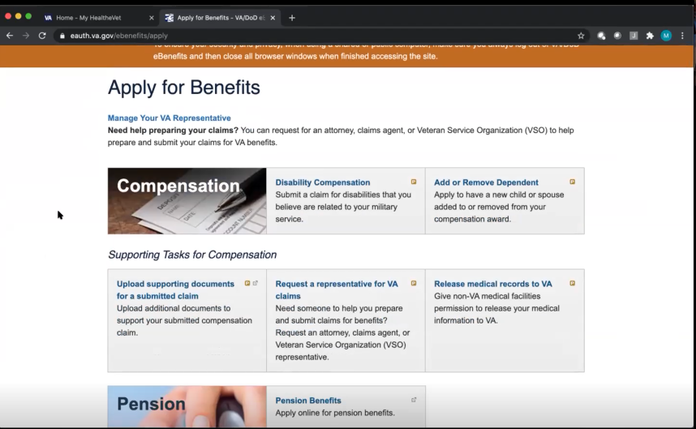

Once you have your rating in place and looking to manage the health care itself is where My HealtheVet appointments, comms, meds and records and other resources are. It is really is a one-stop-shop.

*Points to Resources links in homepage when referring to “other resources” above.*

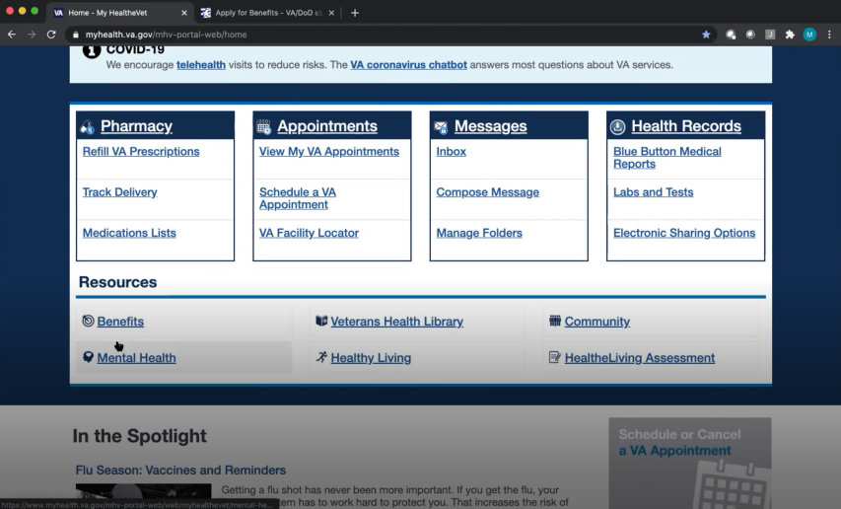

**Have you used those other resources you mentioned?** I have clicked on the benefits one before, mental health I am already pursuing my mental health so I don’t need that. I have done healthy living assessment through other organizations and developed a health living plan through them. For community I have a decent connection to veterans and military due to the fact that 30% of my employer are Veterans, and my client is active duty air force, and I’m still in the reserves. But I know other veterans may feel isolated.

1. **What about “VA health care?”**

I would say it is what you make of it. I would say people need to have realistic expectations of what it can and cannot provide and the timeliness that the services will be provided.

I have friends with great experiences and terrible experiences. One of my Marines it took 4 years for them to realize she needed a hysterectomy at age 30. She was dealing with chronic pain for years and the VA never did the right exams to find what was wrong. This morning she told me after seeing 3 VA docs and being told she doesn’t have eczema they send her the prescription for it. It can be great and it can be terrible.

I don’t think the overall system is screwed up on the federal level. I think the care will depend on the local resources.

The best way to phrase it, go in with low expectations and be pleasantly surprised. It is free for you as the recipient and it is federally run. I’ve worked for the federal government for years and I know the inefficiencies exist and you get what you pay for.

Cynical as it may sound, I think it is better to go in with low expectations and be pleasantly surprised rather than expecting a golden parachute of health care then wondering why they misdiagnose and provide wrong meds for four years in a row.

1. **On a scale from 1-5, with 1 being very dissatisfied, and 5 being very satisfied, how satisfied are you with My HealtheVet?**

I would say 4.5 to 5.

The landing page has everything you need there. Even the fact that it has the option to log directly into the site instead of a DS logon and go to the landing page. The landing page has 95 percent of anything I need to know about my VA health care.

1. **On a scale from 1-5, with 1 being very low, and 5 being very high, how would you rate your trust in My HealtheVet?**

4, I say that because glitches happen, human error. Sometimes you never know what actually happened.

There has been times with communication issues because either the message doesn’t go through or because the provider didn’t check the inbox for messages or the receptionist checked it and didn’t send it to the doctors. It’s not the doctor’s fault but it doesn’t help me any. *Describing functionality issues and responsiveness on the part of VA care team.*

I had a few issues with pharmacy refill.

The appointment thing has been solid.

Medical records, I don’t think it is a My HealtheVet issue but a federal record management issue. I know some stuff is missing from my records.

*Confirmed that there’s been some gaps in accuracy and functionality on MHV.*

**Do you feel your data is secure on MHV?** Yes as much as it can when being on an unclassified government server. I’m sitting here talking to you about it, and I don’t care if they know I have PTSD, it is what it is.

1. **If you have a question about your MHV account or something isn’t working, what do you do?**

What would I do?Contact us button at the bottom normally or FAQ page. Any of those things.

1. **Have you ever been in touch with a My HealtheVet Coordinator?**

Not that I can recall.

1. **How does My HealtheVet compare with other online health tools you’ve used?**

Honestly, it is better than TRICARE. Less clunky than TRICARE’s.

The landing page here is everything I can ask for out of a healthcare landing page.

If this were a private provider the only thing I would add would be a search tool to show which providers are in and out of network. That’s the only thing I’d add functionality wise.

**My HealtheVet patient portal (15 minutes)**

Let's take a look at My HealtheVet together.

Moderator will ask participant to share screen if not already, or show logged in My HealtheVet account. **(5 minutes)**

1. **What do you find the most valuable on this website?**

Probably the prescription refills and easily accessing my own medical records.

I take medication everyday and without being able to effectively refill them I am in a bad spot.

I am still fighting with the VA to recognize my TBI as service-connected. Even though I’m 100% P&T and the VA will treat me for anything, if it isn’t recognized as service connected and things go seriously sideways, there are other benefits that I wouldn’t be eligible for. I’m looking to make sure that I can get it [TBI] service connected in case things so sideways for me in the future.

**Thank you and closing (2 minutes)**

Well we really appreciate you taking the time to share your thoughts with us today. Your feedback is so helpful to us as we continue to work on the site and make sure it really works for Veterans.

Lastly, do you know any other Veterans, caregivers, or service members who might be willing to participate in a future user research session? If Yes: Thank you! I'll have our team send you an email with a little blurb that you can pass along.

Great, well thank you so much again, and enjoy the rest of your day!